|  |
| --- |
| CHANGING SYSTEM SKINS |

Earlier we created a user and assigned a “Skin” to it. This is Cobalt’s Skins feature at work that allows users to customize the look and feel of the system from a selection of color themes.

**CHOOSING YOUR SKIN**

As a user, you can change the current skin of the system by navigating to the “Skin” link on the menu bar.

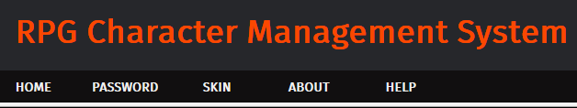

In the Skin Management page, you can select from a variety of available System Skins. Let us change our custom user’s skin to “Modern Eden”.

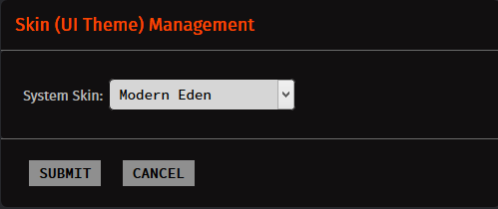

Hit “Submit” and the system should change its color theme using the Modern Eden colors!

